**Asiqul Hoque**

**Section 5 Lesson 3: Set Operators**

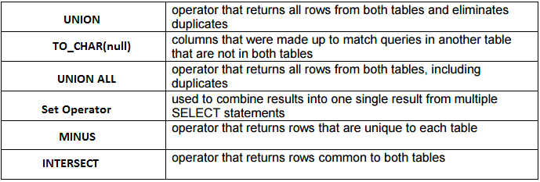

**1. UNION, UNION ALL, MINUS, INTERSECT**

**2. SELECT employee_id, job_id,hire_date,department_id, TO_CHAR(NULL)**

**"start"**

**FROM employees**

**UNION**

**SELECT employee_id, job_id,start_date,department_id,TO_CHAR(NULL) "hire"**

**FROM job_history;**

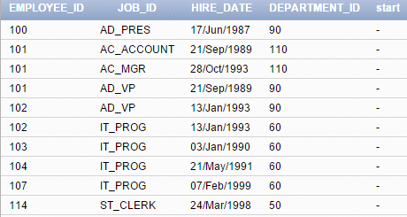

**3. SELECT employee_id, job_id,hire_date,department_id, TO_CHAR(NULL)**

**"start"**

**FROM employees**

**UNION ALL**

**SELECT employee_id, job_id,start_date,department_id,TO_CHAR(NULL) "hire"**

**FROM job_history**

**ORDER BY employee_id;**

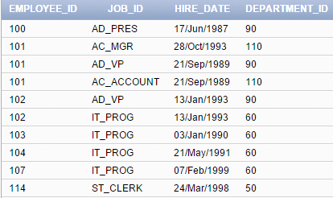

**4. SELECT employee_id**

**FROM employees**

**MINUS**

**SELECT employee_id**

**FROM job_history;**

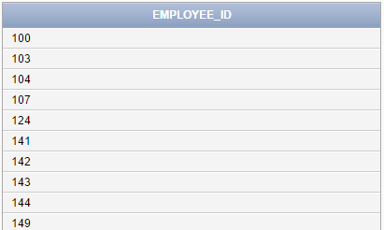

**5. SELECT employee_id**

**FROM employees**

**INTERSECT**

**SELECT employee_id**

**FROM job_history;**

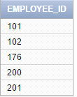

**6. SELECT employee_id, job_id,salary**

**FROM employees**

**UNION**

**SELECT employee_id, job_id,0**

**FROM job_history;**

